Sign up

1) Mobile opt is not coming at a time of sign up

2) Fill up registration form click on submit 🡪 it will redirect to the another page. There is message enter mobile no and verify email address that time I have add a phone number verification code and a message show phone number verify successfully

After that go to email account

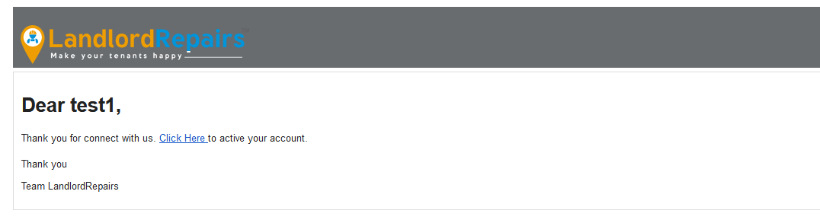

Click here and page redirect to <https://landlordrepairs.uk/preview/verification> page and again a mobile verification code is showing .

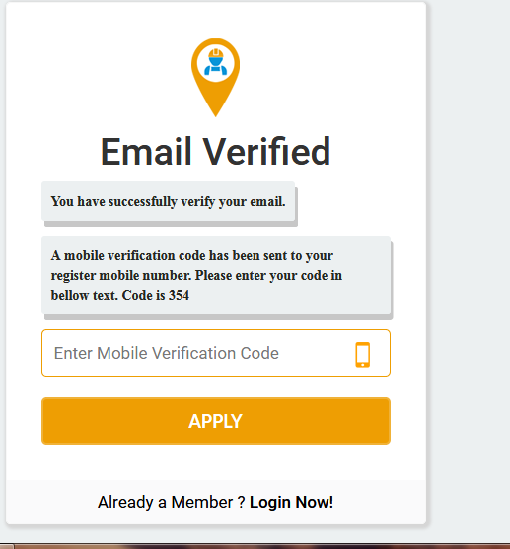

Not replicated.

Edit profile

1) Working Hours From and Working Hours To time cannot be same

2) Each time I want to save, every time I have to enter change password why?

tradesmen-signup

1)<https://landlordrepairs.uk/preview/tradesmen-signup> --> mail not sent

2) Working Hours From and Working Hours To cannot be same 🡪

https://landlordrepairs.uk/preview/my-profile